

Classifying Property Use and Ownership

REPAIR WORKING PAPER

Allison M Orr and Joanna L Stewart

SEPTEMBER 2021

Introduction
Work Package A involves drawing together previously disparate strands of secondary data to construct a non-domestic commercial building stock database for each case study area that contains details of the use, occupier, owner and changes in use of individual commercial properties over the study period. This information is drawn largely from records held in the Non-Domestic Valuation Lists/Rolls, Experian Goad Plans, Land Register/Registry and commercial property transaction services. These databases will then permit examination of the variation in property use and ownership, and how these have changed over time, as stipulated by the following Research Objectives:
RO1: scrutinise the variation in property use and ownership and how these have changed over time.
RO2: examine the spatial patterns in property use and ownership.
RO3 assess the spatial impacts of development.

This working paper details the use and ownership classification systems developed to enable meaningful analysis.

Classifying property use
The starting point in the data analysis process is the need for an appropriate classification which can be used to assign all city centre outlets to a specific type of use in a consistent and unambiguous manner that would facilitate meaningful and accurate analysis of changes in property use and retailing patterns across time points. Guy (1998) identified four common taxonomy methodologies used to classify retail outlets:
- by type of goods sold – many retailers focus on selling a range of goods that can be coherently labelled into a specific product group, such as shoes or jewellery. A weakness of this approach is that it does not deal well with stores when these retailers sell a variety of goods which otherwise have little in common. This includes the variety, department and discount retailers that are present on the High Street.
- by shopping trip purpose – the purpose and nature of a shopping trip made by a shopper, convenience or comparison, are used to describe retailing outlets (Brown, 1992). Convenience stores stock everyday items (such as food and newspapers ) that are bought on frequent, minimum effort shopping trips, whereas comparison outlets are destinations for occasional shopping trips. Comparison shopping involves goods, such as clothing and footwear, electronics and jewellery, which are the type of goods people typically take time to explore their options before making their final purchase. A valid criticism made by Guy (1998) of this classification is that comparison shopping behaviour displayed by consumers does not only occur between retailers but can also occur in large stores that stock wide product ranges. Additionally, some high street retailers, such as Marks & Spencer, stock both convenience and comparison goods.
- by size and type of store – this system attempts to describe retail outlets by store format, and is an established way to differentiate retail developments, such as a supermarket from a hypermarket, and a retail park from a shopping mall. Yet, retailers often employ more than one store format, each tailored in terms of store size, location and product ranges to the needs of the market being targeted. Using store size on its own was criticised by Guy (1998) as it is relative arbitrary and subject to the needs of retailers which change over time. This classification method also does not adequate differentiate the variety of retail offering that exists within standard box units in town centres.
- by store ownership – this classification describes use by type of retailer with the most common distinction made being between independent and multiple retailers although more elaborate classifications exist that sub-divide multiples by number of stores into small and large multiples, and include other ownership types such as co-operatives (Guy, 1998). Independent retailers are retailers that own only one or a small number of shops, whereas multiples own several stores. The relevance of the distinction between these two particular groups of retailers is linked to the perception that the presence of multiple retailers enhances the appeal of a centre to local consumers with neighbouring outlets benefiting from increased pedestrian traffic and sales opportunities. The disbenefits associated with multiple retailers are that they provide fierce competition for rivals in their retail categories and can contribute to the homogenisation of centres and malls whereas independent retailers create product variety and price variability to town centres and shopping malls (Smith and Sparks, 2000). The existence of franchises also blurs the distinction between independent and multiple retailers. Franchising involves an agreement between a product or service provider and franchisee usually pays a fee and fixed percentage of sales to use the brand name of the franchisor. Examples on the high street include Starbucks, McDonalds, and Burger King, and make it difficult to classify these operators by ownership. In additional the definition of a multiple can differ amongst data providers. For instance, Experian Goad defines a multiple retailer as being part of a network of nine or more outlets whereas other information providers define a multiple retail as having two or more outlets.

A fifth classification system, not identified by Guy, is the planning Use Class Order which provides the legal framework that determines the lawful use of a particular property. This use classification is used in Experian Goad Plans and CoStar but the use class systems differ in England and Scotland. For example, food and drink, prior to the Use Class Order introduced 1st September 2020, was classified in the English Use Class Order as retail while in Scotland they are classified as leisure, consequently this can create inconsistencies when comparing different cities.

Both Experian and Local Data Company employ classifications based on a combination of type of goods sold, shopping trip purpose and ownership but the definitions they use differ. For example, the primary activity defined by Experian has at least 287 different categories while Local Data Company has 373. Given that data is used from both data sources, a system is required to standardise the classification between these two systems to create a manageable, yet meaning number of groupings that capture all potential land uses within town centres and can be applied consistently between time periods and across locations. Reclassifying the properties also addresses the occasional inconsistency that becomes apparently when comparing data from the same provider across time periods. For example, an Italian restaurant might be defined as an Italian restaurant in some time points but simply as a restaurant at other time point without the fascia or occupier changing.

The revised classification, which embraces Guy (1998) argument that a classification that combines two or more of the above definitions is the best approach to take, is set out in Figure A1. The system dissects property use into 11 very broad categories: Shops (S); Entertainment, Leisure and Recreation (ELR); Food and Drink (FD); Accommodation Services (AS); Public and Social Value Services (PSVS); Business, Commerce and Office Space (BCO); Industrial (I); Transport-Related (T); Vacant (V); Other (O) and Unknown (UN). Shops are subdivided into broad categories: comparison, convenience and unknown shops. Comparison retailers, as well entertainment, leisure and recreation, food and drink and accommodation services providers, are dissected further into categories by the type of goods or service they provide while convenience retailers are segmented by store format or specialist products sold. Public and social value services are subdivided by property type, such as library, health centre, place of worship, which reflects the type of services they provide to the community. These categories enable the analyses to capture the variation in use while not being dismembered to the same extent as Experian and Local Data Companies as a danger of too many subdivisions is that they hide significant patterns of use.

Appendix 1 breakdown the very broad, broad and low-level property use classification employed by REPAIR. In total there are 67 low-level property use categories.

Classifying property ownership
The ownership of properties is classified by type of investor, unlike many landownership studies that differentiated between public and private landownership (Adams et al., 2002) or by business model which tend to centre around development activities (for example, McNamara, 1983). The classification system employed by the REPAIR research team is similar to that adopted by Lizieri et al. (2011) in their examination of the ownership structure of the City of London office market, as well as by organisations such as CoStar and the Investment Property Forum (IPF) (see, for example, Key and Law (2005) and Key et al., 2018). While there are slight differences in the taxonomy they use, they tend to split property investors into financial institutions, unlisted/collective specialist real estate funds, property companies, individual private investors, traditional owners and ‘other’ which includes public-sector owners and owner-occupiers.

This system is a modified version of the system used by PropertyData.Com and is show in the appendix in Table A2. The main difference is that the sub-types do not differentiate individual financial institution as this level of detail was unnecessary. The identified owner being the holder of the title with “economic use” of the property rights. In Scotland this is typically the heritable interest holder. In England it is the freeholder, unless there exists a long leasehold, which is relatively common in England, then it is recorded as the long leaseholder.

Conclusions
This working paper details the property use and ownership classification systems employed by the REPAIR research project. The taxonomies developed form the basis of the property use and ownership analyses and diversity metrics used in Work Package A and C.

References
Adams, D, Disberry, A, Hutchison, N and Munjoma, T (2002) Vacant Urban Land: exploring ownership strategies and actions, The Town Planning Review, 73(4), 395-416.
Brown, S (1992) Retail Location: A Micro-Scale Perspective, Avebury, Aldershot.
Guy, C M (1998) Classification of retail stores and shopping centres: some methodological issues, GeoJournal, 45(4), 255-264.
Lizieri, C, Reinert, J and Baum, A (2011) Who Owns the City 2011: Change and global ownership in City of London Offices, Real Estate Finance Group, Department of Land Economy, University of Cambridge, UK.
Key, T and Law, V (2005) The Size and Structure of the UK Property Market, Investment Property Forum, London.
Key, T, Moss, A, Chaplin, R and Law, V (2018) The Size and Structure of the UK Property Market: End-2017 Update, IPF Research Programme, December 2018, IPF, London.
McNamara, P F (1983) Towards a classification of land developers, Urban Law and Policy, 6, 87-94.
Smith, A and Sparks, L (2000) The role and function of the independent small shop: the situation in Scotland, The International Review of Retail, Distribution and Consumer Research, 10(2), 205‐26.
.
Appendix

Table A1.1. Overall Property Use Categories
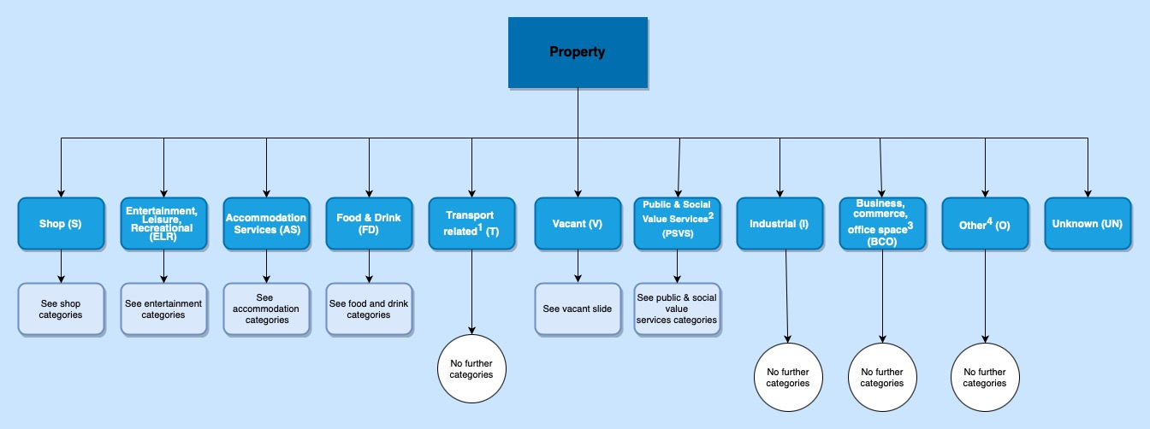

- This includes car parks, bus and train stations.
- This is a category we have constructed to encompass uses which have either a public value/provide a public service such as police stations, council offices or a social value such as a library, community centres and building, Jobs Centre, Citizens Advice Bureau, housing association office, churches. It includes doctors and dentists.
- This is for is for business space where it is not expected that the public will visit on a regular basis (and so excludes banks etc). It includes warehouses and storage.
- Anything that does not fit into the other categories.

Table A1.2. All Shops (S) and Comparison Shop (SN) Categories
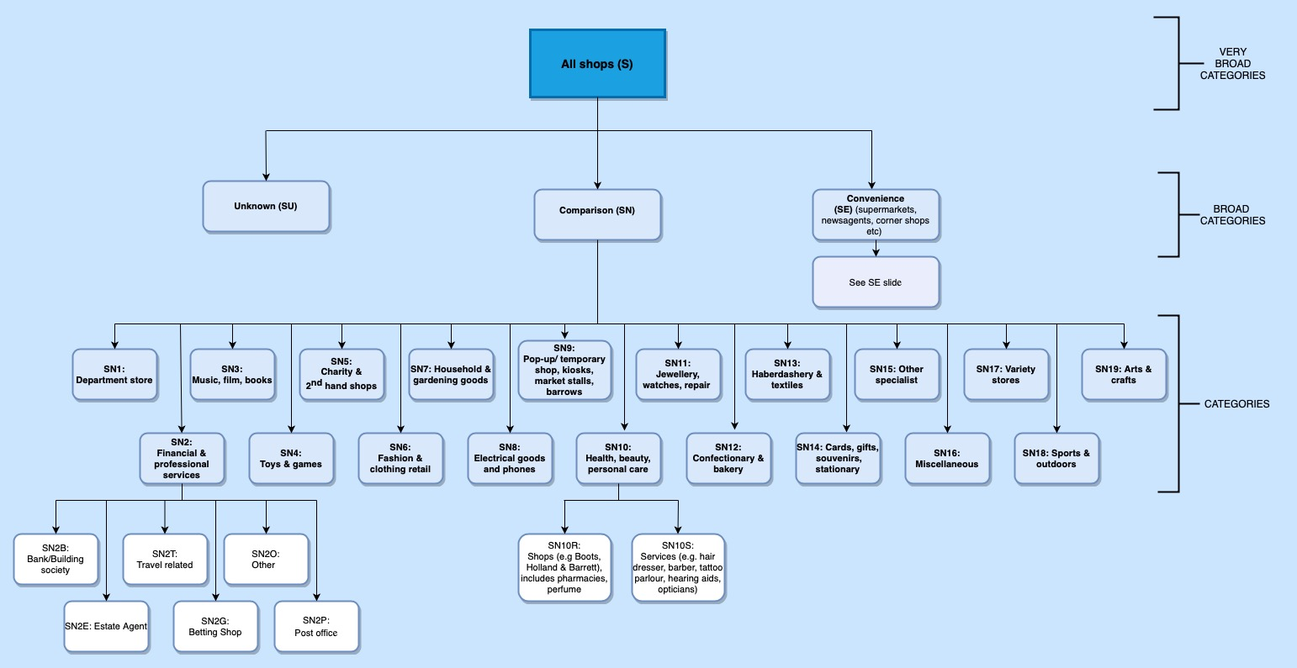

Table A1.3. Convenience Shop (SE) Categories
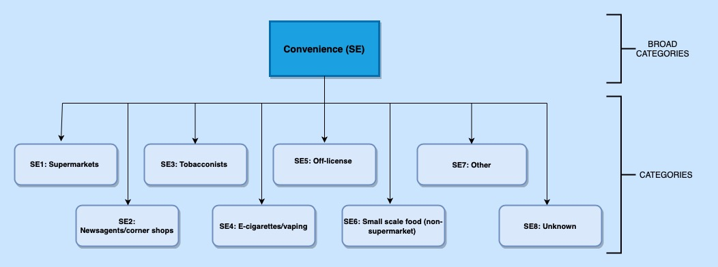

Table A1.4. Entertainment, Leisure & Recreation (ELS) Categories
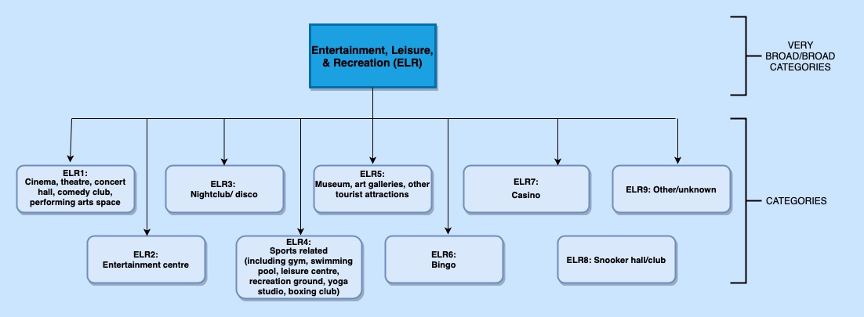

Table A1.5. Accommodation Services (AS) Categories
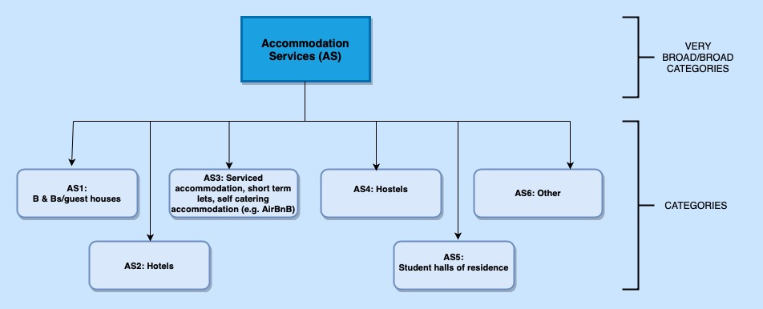

Table A1.6. Food and Drink (FD) Categories
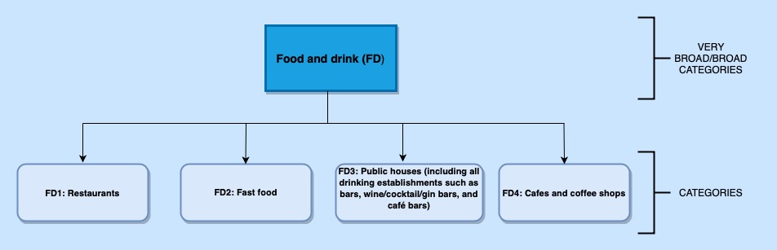

Table A1.7. Vacancies (V) Categories
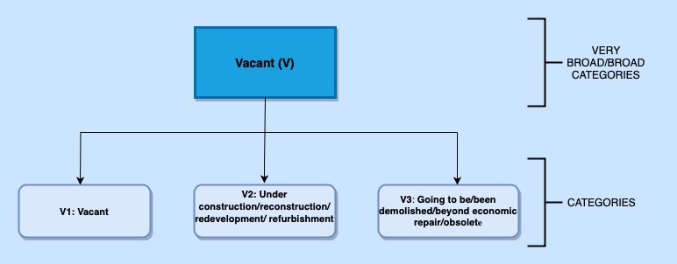

Table A1.8. Public and Social Value Services (PSVS) Categories
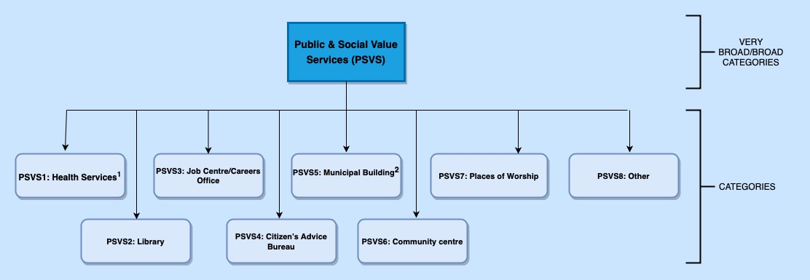

Table A2. Classifying Property Ownership
Type of Investor |  | Investor Sub-types
CI | Corporate Investor. Large companies, typically public limited but also large unlisted companies, whose business model is not set up to lease property to tenants, but find themselves holding surplus space and renting to tenants/sub-tenants. | CON | Partnership, consortium or joint venture involving two or more owners.
OI | Overseas investor. Includes private investors, institutions, and unlisted and listed vehicles where company (or main part of company) is overseas. Includes those listed in Jersey; Guernsey; Isle of Man and Ireland | GOV | National government or government agency
OO | Owner occupier. Any organisation that holds freeholds/heritable interests or long leaseholds to occupy. If space vacant and individual unit surplus to requirements then still classed as OO but if other space in building is let by them recorded as investor. | INFRA | Infrastructure providers
PI | Private investor. Includes partnerships; individuals, charities, churches and private limited companies. Basically, where capital is generally not raised via the retail investment market or listing on stock exchange. Local Authorities (LA) if investing in other localities (not their pension scheme) have been included with the LA sub-type used to give further definition. | LA | Local Authority
UI | UK institution. UK institutions (including banks, insurance companies, assurance companies, large pension schemes, property unit trusts and other collective vehicles) that collect money from the public and place in investments on their behalf. | PI | Private property companies and Crown Estate
UP | UK property company. Includes companies with a main property arm/division/sub-company (e.g. Boots Properties; McDonald’s Real Estate Ltd) set up let space to tenants and franchises as well as manage owner occupied units; specialist businesses that rent out bars and hotels, and LA when operating as a property or regeneration company | PLC/REIT | Listed Public Property Companies or Real Estate Investment Trust
U | Undisclosed/Unknown owner. | RCV | Property when sold was in the hands of a receiver
 |  | SIPP | Private organisations / trustees that administer self-administered pension plans. Includes small directors/partnership pensions but does not include large company pension schemes.

