

REPAIR Case Study Cities: selection rationale and context

REPAIR WORKING PAPER

Allison M Orr, Cath Jackson, James T White and Joanna L Stewart

SEPTEMBER 2021

Introduction

The REPAIR study seeks to develop a holistic understanding of adaptation within a complex urban retailing system by exploring and explaining real estate market outcomes within city centres by undertaking mixed methods research, blending together multi-dimensional approaches focusing on diversity, market practices and social processes within the retailing system. The focus is on the role of real estate innovation, adaptation and power relations in creating vitality and resilience within an urban retailing system.

For this research, a collective case study design is adopted based on the mixed method methodology as described by Mills et al. (2010). A case study approach allows in-depth exploration of the complex issues related to the evolution of use, ownership, and management of retail real estate within a city retailing system, and across different work packages will provide a comparative base for multi-faceted inquiry into transformations, innovations and power structures that have shaped the adaptive capacity of the retailing real estate market.

There are four research work packages (WP), each with its own sampling, data collection, methods and analysis strategies and linked together by common case study cities. The specific methods employed in WPA and WPC are detailed in the work package specific sections of this report while details of WPB and WPD are presented in separate reports. Together they combine positivistic elements of quantitative research methods with constructivist elements of qualitative research methods.

The case studies are five major UK retailing centres, bounded by time and location. The study period spans 2000 to present. Details of the case studies are given below.

Rationale underpinning the case study selection

The research design is based on in-depth case studies of five major UK cities: Edinburgh, Glasgow, Hull, Liverpool and Nottingham (See Figure 1 for their location within the UK). Typically cities, despite our lack of understanding of the spatial processes at play within these significant drivers of urban system dynamics, have been neglected in the ongoing High Street debate with much of the attention being on declining town centres. Focusing on these large cities reflects the pre-dominant focus of private sector investor activity, while the northern sample ensures that the analyses control for north-south economic imbalances, which Wrigley and Dolega (2011) found influential on the resilience of retailing centres. The contrasts between the cities will permit investigation into the urban renewal processes in distinctive cities. The exclusion of London reflects its unique scale, complexity and research challenges, including a retail core comprising a series of distinct but linked centres; its position as a leading global destination and its socio-economic and demographic work/live/visit profile.

Figure 1. Case Study Cities
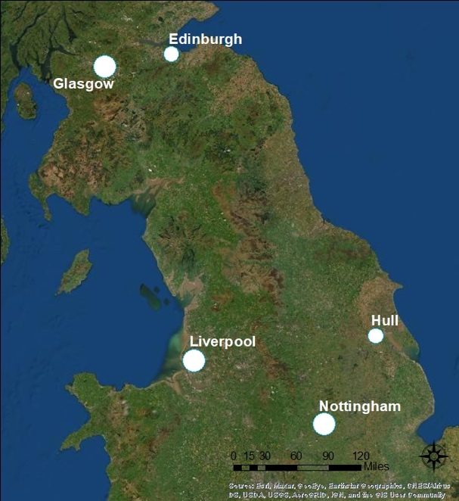

To begin to explore the contrasts between the cities, categorisations and rankings provide a useful starting point. Published categorisations of retail centres have varied significantly, as have the underlying data used to categorise centres, making time series exploration and analysis of the centres a little difficult. None span a comprehensive time series, hindering exploration and analysis.

One of the earliest categorisations still referred to and based on the hierarchical system originally set out by Berry (1963), used multiple retailer count scores to group retailing centres on functionality and classified Glasgow, Edinburgh and Liverpool as three of six “Metropolitan Centres” and Nottingham and Hull as “Major Regional Centres” in 1961. From this base, over time the standings have varied for some and been stable for others and this is explored below. This exploration provides two things. Firstly, it provides justification for their selection for this study, setting out some of their characteristics, which sometimes overlap and sometimes differ, thus seeking to maximise the applicability of the results generated throughout the study. Secondly, it provides some context for the findings that the study generates and helps to contextualise these and the resulting conclusions. Overall, while all the centres are ‘northern’ provincial centres, they have different economic structures and processes of renewal that have given rise to the range of fortunes that can be seen over the last three decades (Reynolds and Schiller, 1992; Harper Dennis Hobbs, 2016). The exploration that follows is not limited to the study period itself, but spans a far wider period to provide a robust context.

Figure 2. Relative Rankings, based on MBS: 1961, 1971, 1984, 1989 and 1995

Source: compiled from Schiller and Jarrett (1985), Reynolds and Schiller (1992), Hiller Parker (1996).

One of the highest profile (and long standing) rankings of retail centres relied on the Multiple Branch Score (MBS) for each centre, developed by Schiller and Jarrett (1985) and updated by Reynolds and Schiller (1992) and Hiller Parker (1996). Exploring this first, the two Scottish centres – Edinburgh and Glasgow – appear similar initially as shown in Figure 2, with high and consistent rankings. However, the MBS data underpinning the rankings, as shown in Figure 3(a), show different trajectories over the last three rankings produced (data for the earlier periods are not available). The MBS scores show high and consistent growth for Glasgow (increases of around 30-40% between each census period), while Edinburgh was much slower to grow initially (a growth rate of just over 10% initially), before then showing the same high growth rate. Despite the MBS scores for both centres growing by over 30% from 1989 to 1995, their rankings do not change.

Figure 3. Relative Changes in MBS for the Case Study Cities
(a) Nominal MBS | (b) Indices, 1984 = 100
Source: compiled from Schiller and Jarrett (1985), Reynolds and Schiller (1992), Hiller Parker (1996).

The three English centres – from west to east: Liverpool, Nottingham and Hull – have highly contrasting MBS rankings, as shown in Figure 2, with Liverpool falling steadily (from 3 to 17); Nottingham fluctuating but, overall, rising fairly steadily (from 12 in 1971 to 6 in 1995); while Hull shows a huge fall from 13 in 1971 to 33 in 1989, before rising equally dramatically and very quickly to 10 in 1995. Underlying these different fortunes, Figure 3 reveals that, like Edinburgh, the MBS for Hull and Nottingham increased by just over 10% between 1984 and 1989, while Liverpool fell (a drop of just one from 71 to 70). However, in the second period, Liverpool regained ground, matching the growth rate of the two Scottish cities, as did Nottingham. The MBS for Hull, by contrast, grew 188%, from 57 to 107. Figure 3(b) shows how much higher this rise was than for any other city in either period.

Various other retail rankings are produced by real estate firms, based on metrics such as catchment (for example, CACI’s Retail Footprint gravity model, which is developed using nine different measures, including quality and quantity of retail provision, and bank spending data) and multiple retailers (such as VENUESCORE, a weighted measure produced by the Javelin Group). These are not freely available.

Figure 4. HDH Vitality Rankings for the Case Study cities

Source: Harper Dennis Hobbs Vitality Index (2014; 2017; 2019)

The Harper Dennis Hobbs (HDH) Vitality Score is one of the more recently published retail ranking. It captures the vitality of a centre by measuring the proportion of up-market shops, the proportion of value-led shops; the vacancy rate, and the proportion of ‘undesirable’ shops weighted by the demographic composition of the centre’s catchment area. The HDH’s Vitality Score, shown in Figure 4 as the centre ranking where a lower ranking equates to a higher relative vitality, demonstrates improvements in Edinburgh, Glasgow and Nottingham and a slight decrease in Liverpool over the study period. The ranking for Hull declined between 2014 and 2017.

A total of twenty factors are combined within Knight Frank’s Top 200 Retail Ranking (see Knight Frank, 2017), grouped into the categories: catchment, expenditure, retail/leisure supply, occupational market, investment market and competition. The raw data for each centre are attributed a score (from a high of 20 for the most desirable, down to 1) to show relative positions. These scores are then summed to provide an overall ranking. The scores across the twenty variables, as well as the overall rankings, are shown in Table A1 for the five case study cities and provide details of the centres at the end of the study period.

As shown in Table A1, Edinburgh is much better placed than any other city in terms of population growth and affluence, as well as expenditure growth (also reflected in the lower HDH vitality score in Figure 4). These perhaps reflect its position as a capital city, attracting an international clientele. However, its supply is significantly physically constrained and thus, as shown in the final column, it is much more susceptible than the other cities (apart from Nottingham, Post-C19) to competition through future changes to local supply.

Other than Hull, no other city stands out as being significantly different from any one other in the Knight Frank 2017 rankings. There are some patterns, such as the consistently high rankings across the sample for catchment size and in-store expenditure, and the low scores for out-of-town provision and online spend. Glasgow and Nottingham are ranked markedly lower for their population growth than the other cities, while the three English cities have lower scores for the per capita spending variable. More nuanced differences can be seen in the Table A1. For Hull, however, there are some clear elements that set it apart. Although it is not out-of-line with the rest of the sample in terms of catchment, expenditure (apart from tourism) and competition, there are clear differences across the supply and occupational and investment market categories. One might expect lower scores for these variables to be driven by lower scores in catchment, expenditure and competition. Yet, retail provision and resilience are still ranked quite high for Hull. The lowest scores are for rental growth and investment demand, indicating a static (and undesirable) market. It might be that there is too much supply, with an insufficient mix of retail and leisure provision within it, for a centre with such a low score for affluence. Overall, however, this indicates that there is a fine balance, between a large number of variables, needed for a centre to score well.

There have been previous attempts to explore retail market indicators, focusing on investment performance metrics, to categorise UK towns and cities to enable comparisons. These are briefly reviewed to draw out some of the characteristics embedded within and underpinning the retail sector. Overall, differential rental levels are often seen as a key indicator of market health and, thus, attractiveness to investors and are found to be explained by the number of national multiple retailers present and the demographic profile of the local population (Jackson, 2001). Thus, for Glasgow, although it is consistently ranked 2nd or 3rd in the UK in terms of its MBS, it has atypically low retail rents due to the comparatively low average spending power of the local population (combined with lower supply constraints) (Jackson, 2001). In terms of spending power, Gibb et al. (1998) found that many of the most deprived areas in Scotland were in Glasgow (and some with the worst levels of deprivation which continues to be evident in the Scottish Index of Multiple Deprivation 2020). This is in line with Knight Frank’s (2017) very low affluence score, but low levels of affluence are seen across all case study cities except Edinburgh. However, Glasgow additionally has low supply constraints, unlike Edinburgh (Jackson, 2001). Edinburgh, however, was found to have a significantly higher than average proportion of its population between 16 and pensionable age, with no dependents, suggesting a high level of disposable income, yet Jackson (2001) found that rental levels did not reflect this. This was based on a cross-sectional model dominated by English towns and cities. It may be that there is a difference between the retail sector in the two countries, suggested additionally by Hoesli, Lizieri and Macgregor (1997) who suggest the “possible influence of local (Scottish) factors such as local anticipated rental growth, risk premia, depreciation and liquidity” (Jackson, 2001, p. 1461). In a similar vein, there have been suggestions of differences in operation between the broadly categorised ‘southern’ and ’northern’ English towns and cities (see Hoesli and MacGregor, 1995; Jackson, 2001). Liverpool and Nottingham were not found to display any differences from similar centres (Hull was not included in the studies by Jackson and Hoesli and MacGregor).

Whereas the discussion of MBS relates to the number of shops, rental change was explored by Jackson (2002) and found that Nottingham at times shows characteristics more common to southern centres. She also found that Edinburgh, Glasgow and Liverpool displayed similar, stable patterns of rental change, common to other freestanding cities or dominant centres (using Champion, Green, Owen, Ellin and Coombes’ 1987 definitions) that were, at the time, declining, “northern million cities” (using Green and Owen’s 1990 definitions). In a later study, Jackson with Colwell found that rents in larger centres, such as Glasgow and Nottingham, are statistically significantly more responsive to changes in consumer spending (Colwell and Jackson, 2004).

Liverpool and Nottingham have been explored by Jackson and Watkins (2005), within a sample of 35 Local Planning Authorities through a survey of policies relating to the retail sector. They found that Nottingham has almost the least constraints to development on the edge of the centre/periphery. By contrast, Liverpool has the most difficulty in land assembly for development, especially at the edge/periphery, but also in the city centre. Similarly, Nottingham and Liverpool are near the opposite ends of scale in terms of healthy market indicators, with Nottingham near the top and Liverpool in the bottom ten markets. It is interesting therefore, in the light of these differences, Jackson and Watkins (2005) found that both markets are in the top 10 for positive rental growth in the period leading up to the survey, 1996-2000. It is possible for these development constraints to have pushed up the rents achieved for prime retail in Liverpool (see Figure 5) over the study period while the top rents achievable in Nottingham have been consistently lower. Rents in Glasgow, initially below Liverpool and Nottingham, have steadily risen above both cities. Edinburgh rents, once above Glasgow, fell and remained below Nottingham, Liverpool and Glasgow until 2017 when they rose above the market rent achievable in Nottingham. Prime rents in all cities have fallen within the last two years, and rents in Hull have remained consistently below the other four cities reflecting its consistently lower ranking.

Figure 5. Prime Town Centre Rents
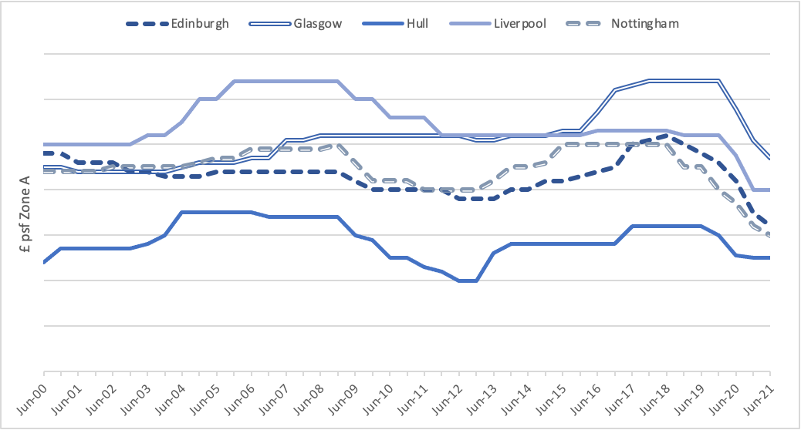
Source: PMA (2021)

Figure 6. Prime Town Centre Yields
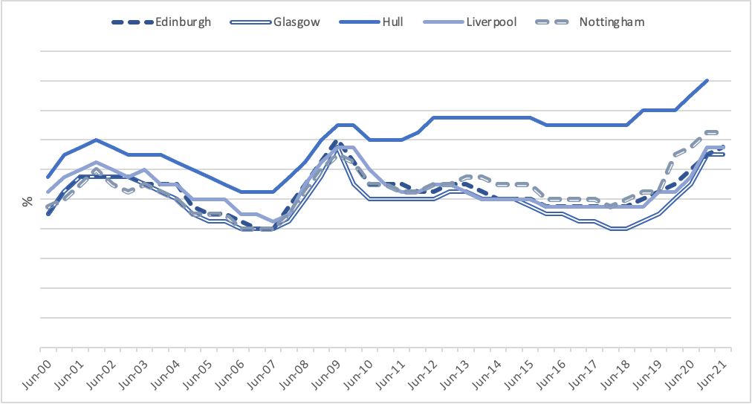
Source: Cushman and Wakefield, cited in PMA (2021)
The trends occurring in the letting market are reflected in prime yields in the investment market. The lower rental growth and higher risks attached to retail investments in Hull are reflected in the city’s higher investment yields although what is noticeable is the divergence since 2010 (see Figure 6). This may be picking up decreasing vitality in this centre which is almost certainly linked to the closure of many high profile retailers and rising vacancy rates in the city centre (See Figures 7).

Figure 7. Vacancy Rates
(a) Prime | (b) Town Centre
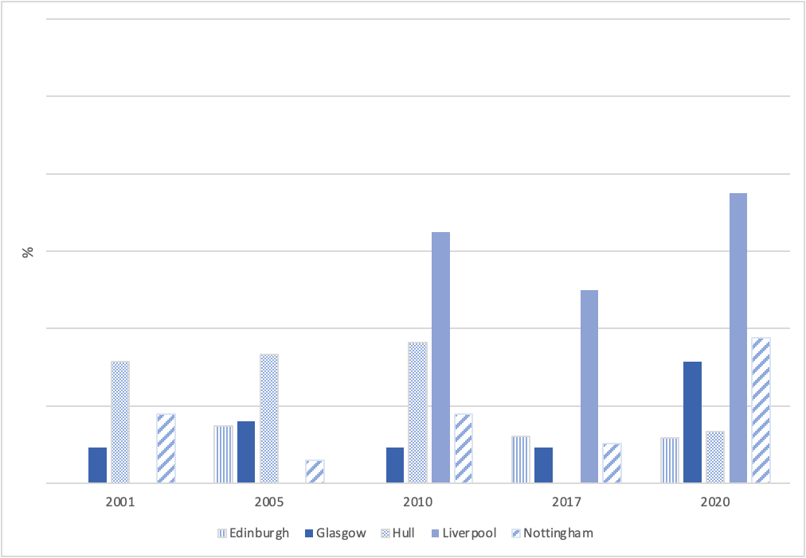 | 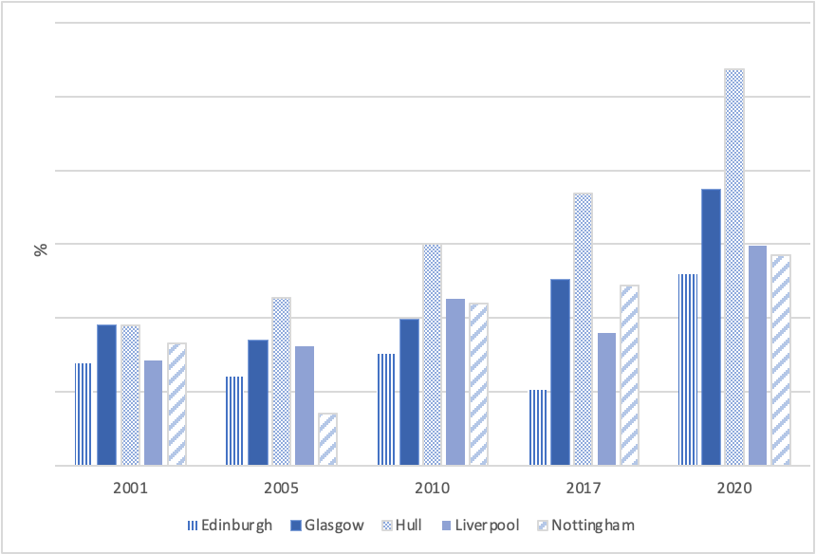
Source: PMA (2021)

Yields in the other four cites (as shown in Figure 6) have tended to fluctuate together with higher rental growth expectations, relatively lower prime vacancies and higher investment confidence in Glasgow appearing to have pushed yields down in Glasgow over the last decade. A noticeable point in Glasgow is the rising city centre vacancies across the time period, like Hull, Liverpool and Nottingham, but the vacancy rate on the prime retailing pitch, as reported by PMA (2021), has been noticeable lower up to 2017. The contrast between zero or significantly lower vacancies on the prime retailing pitches when there are vacancies within the wider town centre is also evident in other cities at different points in time suggesting spatial variation which is giving rise to polarisation in the prime and secondary/tertiary retailing locations, and the prime rents and yields, often used as vitality and viability indicators, are not picking up what is happening across retailing centres. Further, the vacancy rate across Edinburgh’s centre has been lowest 2010 to 2020, possibly explaining why it is placed so highly in the rankings, but the jump in prime vacancies in 2017 suggests there are disproportionate effects on prime retail units. A similar surge in prime vacancies occurred in Nottingham in 2020. Again suggesting different retailing locations in the city centre are behaving differently although in these instances the spikes could be linked to the closure of large retailers which typically formed part of the prime retail area.

It is the mixed fortunes of these city centres that underpin the rationale for selecting these five northern cities for study. At times their performances have contrasted while at other times behaved similarly. Furthermore, the stability of some centres and reversals in the ranking of others provide a breadth of experiences that should yield meaningful and applicable insights into the changes that are occurring within urban retailing systems in the UK.

Defining the retail study area with case study cities

The focus of this study is the core retailing location within the five case study cities so an appropriate definition of retailing centres is required. Numerous systems exist to define and classify retail locations in the literature. Until recently these approaches relied on definitions linked to shopping behaviour and the notion that shoppers would shop at the nearest or most convenient location. The simplest of such classification is the differentiation between convenience and comparison shopping, however Guy (1998) argues that this distinction is less relative in today’s retailing market as variety/mixed stores and leisure shopping have blurred the lines of demarcation.

Guy (1998) defines a retailing area as an unplanned cluster of shops that tend to develop and grow through the gradual conversion of buildings and land from other land uses. The areas tend to consist of many separate buildings that are owned by a number of property owners. These unplanned retail outlets are typical of the traditional “High Street” in our cities, towns and suburbs where property ownership maybe fragmented and the physical appearance of units is typically not uniform or standardised. These linear shopping ribbons differ from a shopping centre/mall which is a planned group of retail outlets, usually in a single purpose-built or converted building, and identifiable physical appearance (Brown, 1991). More recently, Ordnance Survey took a similar approach to Brown, defining a High Street to be any cluster of 15 or more buildings, less than 150 metres apart, containing retail or food and drink units along a single road (Ordnance Survey, 2019).
This study aims to look beyond single streets but at how streets and buildings within the core retailing area change. A primary shopping area (PSA) in England is defined in the National Planning Policy Framework (Ministry of Housing, Communities and Local Government, 2019) as the 'defined area where retail development is concentrated' although some planning authorities, refer to the city centre PSA as main retail area. In Scotland the retail core in a city or town centre is referred to as the principal retail area (PRA) and is identified by the controlling Local Authority as the preferred location where retail development is encouraged (Scottish Government, 2014). These policy-defined in-town shopping areas capture the traditional unplanned linear ribbons and adjacent shopping malls within the central retail and commercial districts within cities and towns.
The PRAs and PSAs in the case study centres have changed over time as the retail centre evolved. Figure 8 illustrates the changes to the boundaries of the city centre retail core, as set by local and development plans and strategic policy guidance, for each city over the study period.
In some centres, such as Edinburgh and Glasgow, the designated core retail area has changed very little. In other centres, such as Liverpool, there has been considerable changes. Following consultation with the REPAIR Steering Group the decision was made to set the study retail area within each city for the study as the areas that corresponded to the maximum area of coverage when the PRAs and PSAs for different time periods were merged. It was also decided that the extension to Edinburgh’s PRA across North Bridge, which was present in the 2010 City Plan but removed in 2016, was disconnected to the main retail core and excluded from the study area, as was the London Road strategic area in Liverpool.

The agreed study city centre retailing areas, highlighted in the above maps in pink shade, form the basis of the micro-level analyses that are explained in Chapters 5 and 6. In additional, a buffer zone, shown in red, was created around the defined retailing zone to avoid boundary problems associated with edge effects.

Figure 8. Study Areas Definitions
(a) Edinburgh’s Principal Retail Area Boundaries and Study Area
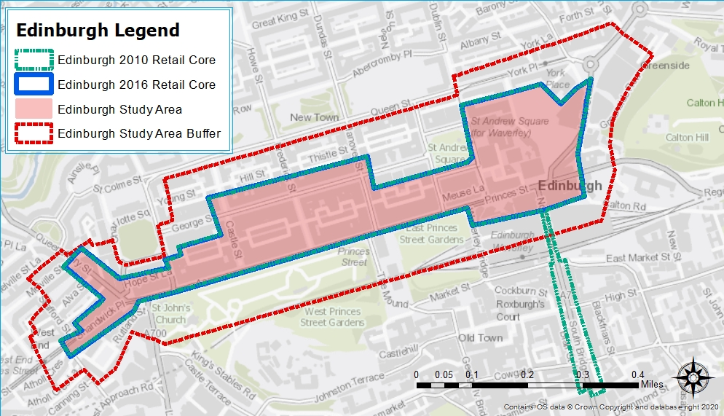
(b) Glasgow’s Principal Retail Area Boundaries and Study Area
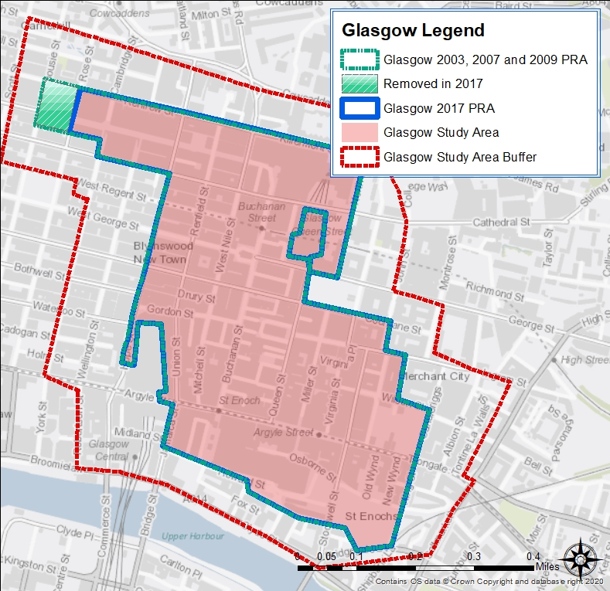

(c) Hull’s Primary Shopping Area Boundaries and Study Area
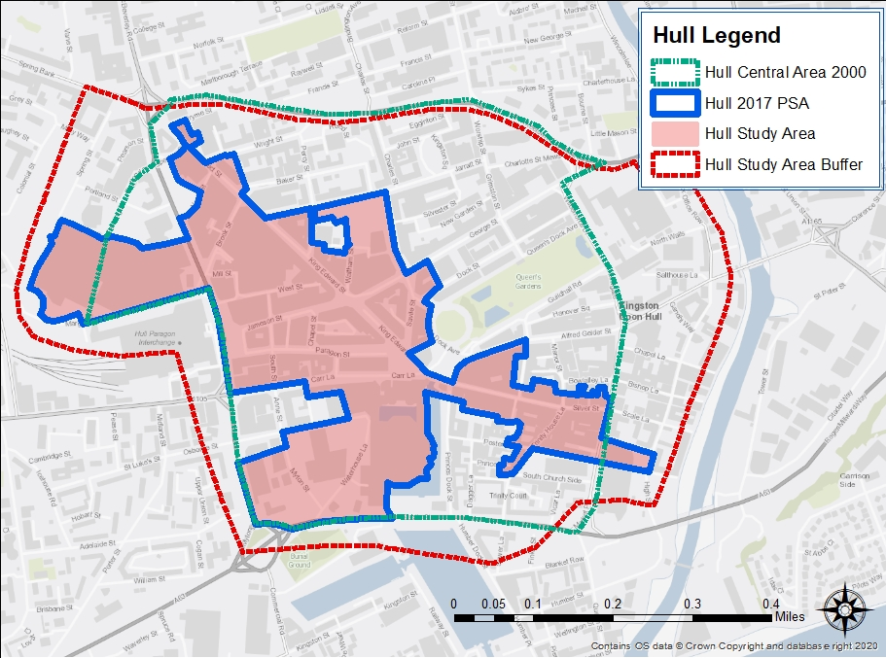
(d) Liverpool’s Primary Shopping Area Boundaries and Study Area
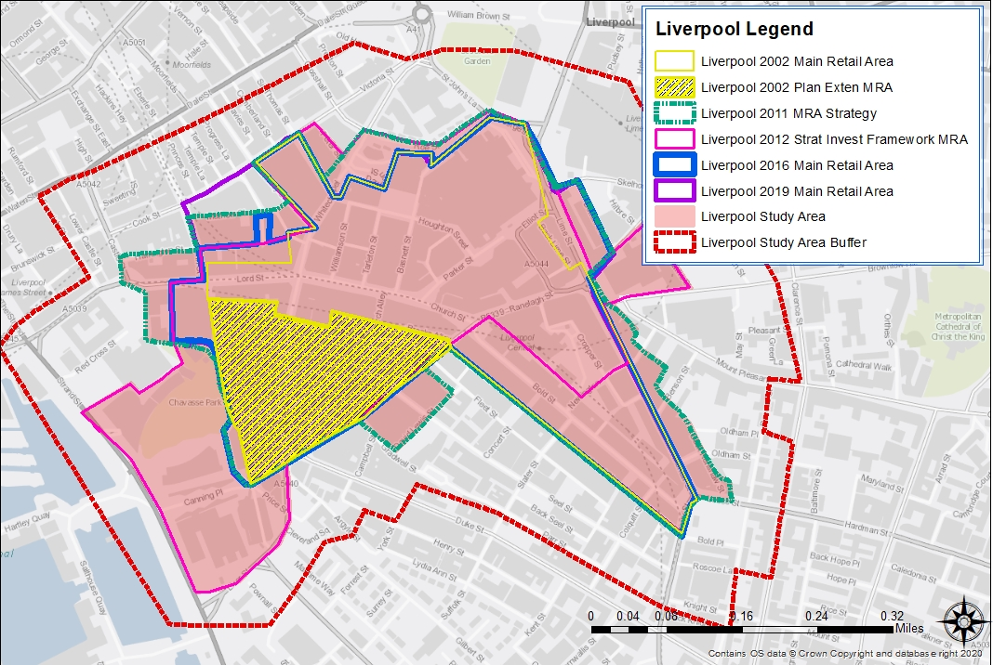

(e) Nottingham’s Primary Shopping Area Boundaries and Study Area
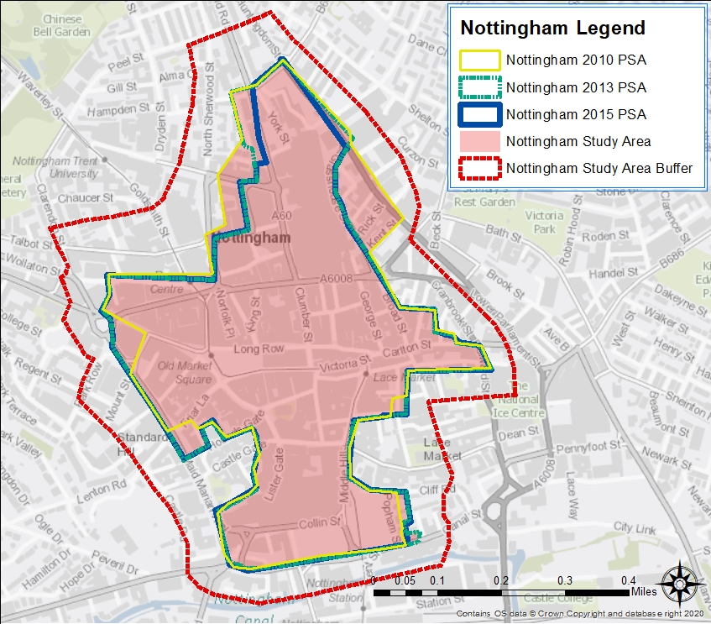

In spatial analysis, boundary effects are a form of bias that occurs in statistical analysis when a neighbouring unit of analysis is excluded but influences the values of its neighbours. This is a particular problem when using spatial point data. A common technique used to avoid this bias is to include a buffer zone where property units beyond the retail core are examined in terms of their effect on points within the study area but are not analysed in any other way so that edge effects are eliminated from the study area (Fotheringham and Rogerson, 1993). Rather than pick an arbitrary buffer zone distance, zones two street blocks wide were set around the boundary of the study areas to capturing spatial processes that might affect the units internal to the study area. The retailing study areas and buffer zones are shown in Figure 8. The actual width of buffer zones varied across cities due to street patterns, and allowances made for the presence of open and physical features such as canals, rivers and dual carriageways. In Edinburgh the buffer zone width varied between 15.9m and 178.9m; Glasgow between 65.7m and 194.6m; Liverpool between 50.3m and 205.5m; and Nottingham typically between 64.2m and 145m although at one point is 272.7m wide. The buffer zone for Hull was set wider than the buffers used in the other four cities to capture possible wider interactions with the main retailing core as there was no primary shopping area policy definition until the 2016 city plan which was not adopted until 2017.

Context: the retailing and economic landscape of the case study centres

Edinburgh
Edinburgh is the second largest city in Scotland with the designated retailing area under study in Edinburgh covering a 0.304 km² (0.114 square miles) area. It contains the smallest retail core of the five retail systems under study with an estimated 158,000 square metres of retail accommodation, as at 2017/18. The greatest provision of space is as retail ribbons on Princes Street, which provides the mainstream retail provision, and George Street, the home to more upmarket retailers and bars and restaurants. Retail and food and drink (F&D) units are also located on Castle Street, Hanover Street, Frederick Street and pedestrianised Rose Street with the current retail, food and drink and leisure offering in the city representing around 8% of the local economy (ONS, 2019). Additional retail accommodation (summarised in Table 1) is provided in two managed malls located on the eastern side of Princes Street – 16-34 Multrees Walk and the Waverley Mall. Princes Street has traditionally been the prime retail pitch in the city. The St James Centre which previously provided around 41,800 square metres closed in 2016 for redevelopment. The replacement, St James Quarter, is a mixed-use open air shopping mall, estimated at a cost of £1 billion, with the first phase opening in 2021 and will host 85 shops, 30 restaurants, two hotels, 152 residential apartments and a cinema when completed.

Table 1. Retail Floorspace in Edinburgh
Type of Floorspace | Estimated Floor Area | 2017/18 Size (square metre) | Mall Opening | Refurbishment/Extension
Metropolitan Centre – Edinburgh
“High Street” units | 129,747
St James Centre |  | (41,800) | 1973  (closed 2016) | Redevelopment started 2016  Major Refurbishment 1997/8  Extended 1990
16-34 Multrees Walk |  | 20,253 | 2002
Waverley Mall |  | 8,000 | 1984 | Refurbished & extended 2020 to 9,400sqm  Refurbishment 1992
Est. Total Floorspace | 158,000
Source: Compiled from CoStar, Completely Retail, PMA (2020a).
Edinburgh is a compact city with around 513,000 residents in 2017. Having grown by 12.5% between 2007 and 2017, the city now has a population density of 1,950 residents per square kilometre and is more than half the population density in Liverpool and Nottingham which have amongst the highest densities in UK major cities outside London. 31,600 residents live within the city centre (The City of Edinburgh, 2018). In addition, it is a relative affluent city with the second-highest gross disposable income outside London, the lowest rate of unemployment of all the major UK cities and gross value added (GVA) at an average of £44,200 per resident (The City of Edinburgh, 2019).
The city is the administrative capital of Scotland where the Scottish Government, Scottish Parliament and supreme criminal court are situated, reflecting the 23% of GVA generated in the city by public administration, health and education (ONS, 2019). Banking and financial services is another key sector of Edinburgh’s local economy with the city currently ranked 13th in the Global Financial Centres Index 28 (Wardle and Mainelli, 2020). Science and technology, including electronics, gaming, energy and medical science, are other important employers with approximately 38,4000 workers employed in the digital tech industry in 2017 (The City of Edinburgh, 2018).

Edinburgh is also an attractive tourist destination as a UNESCO World Heritage Centre, drawing 2 million overseas visits in 2017 and is the 2nd most popular city visited by overseas visitors in the UK (VisitScotland, 2018a). Summer festivals, such as the Fringe Arts Festival, Comedy Festival and Book Festival, and the Christmas and New Year celebrations are popular with international and national visitors. The World Heritage area covers the Old and New Towns of Edinburgh which is an approximate 4.5km² area within the city centre. As a consequence of the measures in place to protect and manage the designated area, as well as the city’s greenbelt policy, tight development controls exist within and at the edges of the city to minimise the impact of new development on the heritage of the centre. Around 6,120 hotel rooms have been completed between 2002 and 2017 to accommodate the growing visitor numbers but the majority of new hotel space has been located on the edge of the centre, mainly at South Gyle, to safeguard the historic character of the centre (The City of Edinburgh, 2018).

The city has a large student population. There are three universities located within the city - Edinburgh University, Edinburgh Napier and Heriot Watt. Together these universities hosted over 55,300 undergraduate and postgraduate students in the city in 2017/18 (The City of Edinburgh, 2018). The largest university, University of Edinburgh, attracted 45% of its student base from domiciles outside the UK (University of Edinburgh, 2019). The growth in student numbers over the last decade is reflected in the 9,800 additional purpose-built student rooms developed between 2007 and 2017 in the city. The city also has a highly skilled workforce with 63.9% of residents holding first degrees or higher (The City of Edinburgh, 2018).

To improve connectivity within the city and relieve traffic congestion a new tram system was launched in Edinburgh in 2014. The 14.5 kilometre of line took six years to construct and links Edinburgh Airport on the western edge of the city to the city centre, running partly along Princes Street. This new tram system was highly controversial at the time due to the cost and time over-runs, and disruption the construction work caused to the city centre. A positive outcome is that the new system has contributed to 33.7% decrease in carbon dioxide emissions per capita between 2010 and 2017 although levels in Edinburgh remain second highest out of the major UK cities (The City of Edinburgh, 2019). Princes Street is also reasonably well served by bus and train services. The city’s principal railway station Waverley is accessible from Princes Street while buses run the length of Princes Street to the bus station which is situated on Elder Street, to the rear of the Multrees Walk. Edinburgh, compared with other UK major cities, is poorly served in terms of car parking with the closure of the car park at St James making the shortage more apparent.

Glasgow
Glasgow is the largest retail centre in Scotland with a wide catchment. The core retailing area under study is the largest at 0.66km² (0.255 square miles) and provides a significant source of employment. Retail (defined as wholesale and retail trade) provides 50,000 jobs in the city which represented 12.5% of city employment in 2017.

City centre retail space is estimated to be above 288,000 m² with managed mall space providing a substantial share of this floorspace. The traditional “High Streets” in the city were Argyle and Sauchiehall Streets, now linked by Buchanan Street, form what was referred to as the Golden Z although more recently has been marketed as The Style Mile. As shown in Table 2, there are seven malls within The Style Mile. Argyll Arcade, a traditional Victoria arcade that specialises in jewellery while Buchanan Galleries, St Enoch, and Sauchiehall Centre focus on mid-market comparison retailing while the Italian Centre and Princes Square accommodate high-end retailers. The Savoy Centre contains street level units accommodating national multiple retailers, and over two levels of outlets geared toward smaller independent, local retailers with the ground level repurposed in 2019 as the Colab creative hub (although this appears to have closed as a consequence of the pandemic).

Table 2. Retail Floorspace in Glasgow
Types of Floorspace | Estimated Floor Area | 2017/18 Size (square metre) | Mall Opening | Refurbishment/Extension
Metropolitan Centre – Glasgow
“High Street” units | 77,983
Argyll Arcade |  | 7,152 | 1829 | Refurbished 2011
Buchanan Galleries with Buchanan Quarter |  | 70,784 | 1999 | Extended 2013 to add Buchanan Quarter
Italian Centre |  | 1,580 | 1991
Princes Square |  | 11,900 | 1986 | Refurbished 2018/19  Extended 1998/99
Sauchiehall Centre |  | 18,070 | 1974 | Refurbished 2002  Refurbished & extended 1987
Savoy Centre |  | 8,761 | 1970 | Refurbished 2018/19
St Enoch |  | 120,770 | 1989 | Redevelopment started 2019  Extended 2009/10  Refurbished & extended 1998/9
Est. Total Floorspace | 317,000
Source: Compiled from CoStar, Completely Retail, PMA (2020b).

Relatively little retail development has occurred in the city over the study period, following the opening of Buchanan Galleries in 1999. There was the addition of 51,000 m² and repurposing of space in the St Enoch Centre in 2009/10 and the creation of 9,500m² at Buchanan Quarter (part of Buchanan Galleries) but the large southern extension to Buchanan Galleries, proposed by owner Landsec, stalled in 2015 and plans are now in the pipeline to develop it as an office-led development with a smaller retail element (January 2022 update - to develop it as a neighbourhood district with residential, office, retail, new streets and public realm). Subsequently, the city’s retailing system is unusual in that the floorspace per head (see Figure 9) is notably lower than in the other cities within the study, even Edinburgh prior to the withdrawal of the St James Centre from the market.

Figure 9. Floorspace per Head of Population
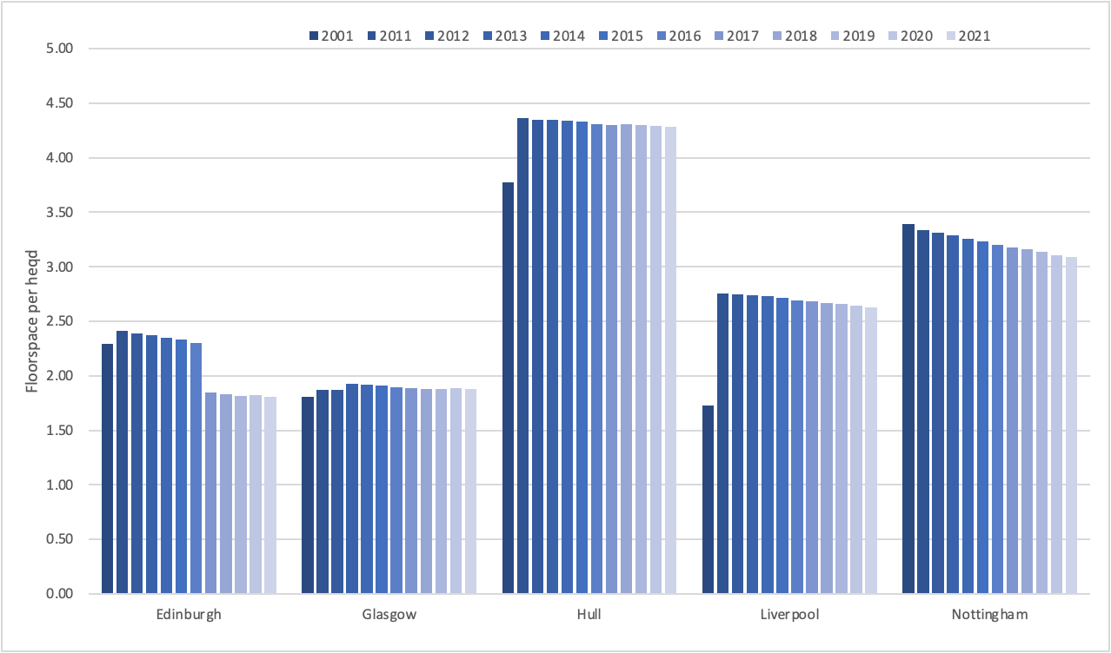
Source: Adapted from PMA (2021).

Once a manufacturing powerhouse, the restructuring of Glasgow’s local economy has resulted in only 4.5% of the jobs in the city being in manufacturing with the service sector now dominating, representing 84.9% of GVA (nomis, 2020; ONS, 2019). Public administration, health, defence and education represent 20.8% of the economy while retailing and leisure contribute to 9.5% of economic output. Other notable sectors include financial services which now represents 9.4%, real estate activities 10.5% and 8.1% generated by information and communication, including its substantial media and publishing industry (ONS, 2019). The Glasgow economy also has an expanding tourist base, attracting 789,600 international visitors in 2017 (VisitScotland, 2018b) with visits spread relatively evenly throughout the year. Tourism now contributes £432 million per annum to the Glasgow economy. Footfall in the city during the spring and summer months is higher than footfall in the Liverpool, Nottingham and Edinburgh although this dips in the winter months suggesting residents and visitors are less inclined to visit the centre when the weather worsens (See Figure 10).

The city it served by a rail, bus, and underground system that has largely unchanged in the last 30 years although the underground system and its stations have been undergoing refurbishment and in October 2017, one of the two main railway stations, Queen Street station started a process of redevelopment. The golden Z is well serviced by these public transportation connections with subway stations at the top and bottom of Buchanan Street, two stations on Argyle Street, including the main Central Station, and Queen Street station accessible from Buchanan Street. There are also numerous multi-storey car parks in the city centre with every point in the study area within a 400 metres walk of car parking.

Figure 10. Average Weekly Footfall
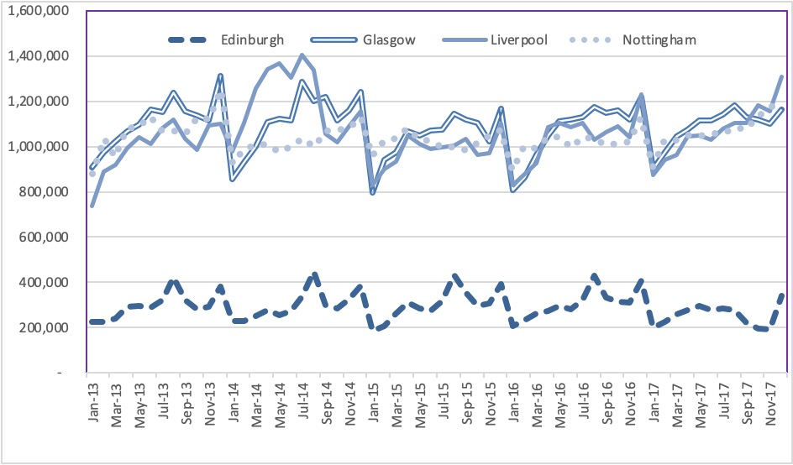
Source: Springboard. Economic and Social Research Council. Springboard's Footfall Benchmark Data, 2018 [2019]. University of Glasgow - Urban Big Data Centre and Liverpool Bid Company.

Buchanan Street and sections of Sauchiehall and Argyle Streets are pedestrianised. Work was undertaken in 2018/19 to rejuvenate the non-pedestrianised end of Sauchiehall Street as part of The Avenues Project. This was the first phase of a larger transformation to the city centre, funded by £115million Glasgow City Region City Deal, to improve the accessibility of the city and involves plans to provide an integrated network of continuous pedestrian and cycle routes, improve the public realm and reduce on-street parking.

Another important change to Glasgow’s retailing area has been triggered by two large fires on Sauchiehall Street. The first was a nightclub in March 2018 which closed a section of the street for three months and a break now exists in the retail frontages as a building had to be demolished. The second was the School of Art fire in June of the same year, just four years after another fire that caused severe damage to the structure. These fires have had a significant and lasting impact on retailers and leisure operators, contributing to a physical decline in Sauchiehall Street.

Hull
The second smallest of the case study retailing areas is Hull which covers 0.335km² (0.129 square miles). Retail floorspace in Hull’s city centre constitutes 174,000m² with retail, food and drink and leisure contributing 8.5% of GVA generated by the local economy. A total of 19,000 workers work in retail (15% of the city’s workforce) (ONS, 2019; nomis, 2020). The city’s retail offering (summarised in Table 3) comprises three malls – The Prospect Centre, Princes Quay and St Stephen’s Centre – and two old Victorian arcades that provide space to small independent retailers. Traditionally, the prime retail frontages comprised Jameson Street, King Edwards Street, Prospect Street and Whitefriargate. The most recent retail development - St Stephen’s – was driven by a public-private partnership, as part of a regeneration initiative, to improve the city’s retailing offering and included a hotel and the Hull Trunk Theatre as part of the re-development package.

Table 3. Retail Floorspace in Hull
Type of Floorspace | Estimated Floor Area | 2017/18 Size (square metre) | Mall Opening | Refurbishment/Extension
Major Regional Centre – Hull
“High Street” unit | 49,375
Hepworth Arcade |  | 916 | 1890
Paragon Arcade |  | 655 | 1891 | Refurbished 2017/8
The Prospect Centre |  | 30,073 | 1975 | Extended 2003  Refurbished & extended 1989
Princes Quay |  | 41,881 | 1991 | Extended 2017  Refurbished 2015  Refurbished 2007  Refurbished 1998
St Stephen’s Centre |  | 51,100 | 2007
Est. Total Floorspace | 174,000
Source: Compiled from CoStar, Completely Retail, PMA (2020c).

In terms of affluence, PMA (2020c) rank Hull relatively low. Partly due to the city’s higher than average percentage of economically inactive residents which accounted for 24.5% of the 260,000 residents in 2017 (nomis, 2020). The population of the city has grown by 3.1% since 2000, driven by Hull City Council’s strategic objective which has given rise to a number of residential conversions within the city centre.

Hull was the UK City of Culture in 2017 which stimulated growth in tourist numbers visiting the city and Humber region. Tourism in 2017 was worth £313 million to the city economy, growing 27.7% over the preceding five year period. Total visits to Hull hit 6,200,000 in 2017 although this is largely dominated by domestic visitors as only 44,000 overnight stays of a total 416,000 were made by international visitors. The total employed in tourism in 2017 was 6,735 (Berriman, 2018) although the effects of the pandemic are likely to have had a significant impact on the numbers visiting the area in 2020 and 2021.

The city’s economy has traditionally been structured around The Port of Hull and port related activities. While the port declined in the 1970s and 1980s, it has recovered in recent years with transportation and storage representing 5% of the local economy in 2017. Manufacturing made up 28.7% of GVA in 2017 while production and services accounted for 31.6% and 62.6% of the local economy, respectively. The public sector is the biggest employer in the city, providing 36,000 jobs (28.8% of all jobs) (nomis, 2020).

The public sector has been proactive in regenerating Hull, spending £25 million to deliver a public realm strategy in the city centre that has seen substantial improvements to the streets and open spaces in and around the retailing area of the centre. The local authority has also led on a number of significant regeneration projects, including £80 million invested to convert disused warehouses into food and drink outlets in the historic Fruit Market, and £10million has been spent on the city’s Old Town, now a Heritage Action Zone, including the refurbishment of Trinity Market. The Bonus Arena, a state-of-the-art music and events complex, was opened in 2018 (Invest Hull, 2020).

Hull has seen infrastructure improvements over the last 20 years although road congestion during peak times remains an ongoing issue. The most significant development being the integrated train and bus station at Paragon Interchange which was developed as part of the St Stephen’s retail development in 2007. The pedestrianisation on King Edward Street was also extended in 2016 to tie it in with the rest of the pedestrianised city centre. Another improvement has been the opening of a footbridge over the River Hull in 2013, linking the Old Town with the East Bank, while a new bridge crossing the A63 to link the city centre with Hull Marina opened in 2021. Hull City Council also plan to upgrade the A63 to improve the road network around the city centre and port area.

Liverpool
Liverpool is the principal retailing centre serving Merseyside. It is the second largest city in the northwest of England with Manchester, the largest, only 34 miles away from Liverpool. The resident population living in Liverpool was 491,500 in 2017, having grown by 10.2% over the study period (nomis, 2020). Liverpool with three universities - University of Liverpool, John Moore University and Liverpool Hope University – has a large student population living in the city. The number, estimated at 29,060 in 2017, had doubled since 2006 (Jackson, 2018).

Table 4. Retail Floorspace in Liverpool
Type of Floorspace | Estimated Floor Area | 2017/18 Size (square metre) | Mall Opening | Refurbishment/Extension
Major Regional Centre – Liverpool
“High Street” units | 45,305
Cavern Walks Centre |  | 10,219 | 1984
Central Station |  | 7,711 | 1984 | Major refurbishment 2002
Clayton Square Centre |  | 16,000 | 1988 | Refurbished 2014  Extended 2004  Redeveloped 1996
Liverpool One |  | 152,200 | 2008 | Extended 2016  Refurbished 2015
Metquarter |  | 14,120 | 2006 | Refurbished 2018
St John’s Shopping Centre and Market |  | 33,445 | 1969 | Major refurbishment 2015  Refurbished 2013  Refurbished 1999
Est. Total Floorspace | 279,000
Source: Compiled from CoStar, Completely Retail, PMA (2020d).

The retailing area under study in Liverpool covers an area of 0.458km² (0.177 square miles). Over the study period the retail floorspace has changed considerably due to two significant developments. The first was the conversion of the old post office building into Metquarter in 2006, followed by Liverpool One in 2008, as detailed in Table 4. Liverpool One was public sector led as a major regeneration project to revitalise a large part of the city centre and strengthen the position of the city as a major retailing centre. This is a modern open area shopping development that comprises pedestrian streets, and new and converted structures that link directly into the existing street network. Liverpool One also includes a cinema, two hotels, residential apartments, numerous restaurants, car parking, and five acres of landscaped gardens, Chavasse Park, used for entertainment and leisure activities.

Church Street and Bold Street represented the traditional prime frontages in Liverpool with Lord Street, Parker Street, Whitechapel, Williamson Square and Ranelagh Street providing additional street level frontages. These streets (with exception of Ranelagh Street) are pedestrianised, as are many of the narrow side streets to the north of Lord Street and Chapel Street. Four other shopping malls exist in the city centre. The oldest is St John’s Shopping Centre which tends to target discount-led retailers while Metquarter as well as, Cavern Walks Centre, targets high-end retailers. The other shopping centres are Central, which provides access to Central Railway station and fronts Ranelagh Street, and Clayton Square Centre. Queen Square, redeveloped in 2000/1, lies to the north of the main retailing streets and has become an established location for food and drink operators. Retail, food and drink and entertainment represent 15% of economic output in the city (ONS, 2019).

PMA (2020d) categorise the Liverpool retail catchment area as one of the least affluent areas in England. They saw little change in the first half of the study period but this has improved more recently due to the fall in unemployment (5.3% as at 2017, falling from a high of 10.8% recorded 2009/10) and general economic growth in the area. However, the average gross weekly wage in the city remains lower than the average for the North West region (nomis, 2020).

Renown as a port with a long maritime history, shipping and port related activities remain important in the city with transport and storage generating 5.5% of the economic output in 2017, albeit down from 6.2% in 2000. Manufacturing and production have also contracted over the study period. Previously 12.6% and 14.6% of GVA generated in 2000, they represented 9.3% and 10.6% in 2017, respectively. Over the same period the service sector grew by 36.8% and now represents 84.7% of GVA generated by the local economy (ONS, 2019).

Liverpool has established itself as a major tourist destination as a legacy of its European Capital of Culture status in 2008. In 2015 there were approximately 1.43 million trips to Liverpool which, generated about £294 million in expenditure (Kantar TNS, 2018). Of the visitors in 2017 over 111,000 travelled into the city via the Liverpool Cruise Terminal which opened in 2007 (Bond, 2017). Top visitor attractions tend to be located along the city’s waterfront, just to the south of the retailing centre, and includes the historic Albert Dock and Tate Liverpool , Mersey Maritime Museum, Open Eye Gallery and The Beatles Story.

Liverpool is relatively well connected. It is well integrated into the national road and rail network with a choice of River Mersey crossings - two road tunnels directly connecting the city to the Wirral and the M53, the Silver Jubilee Bridge, and the Mersey Gateway Bridge, which is a toll bridge that opened 2017. Two rail lines (the Wirral Line which links Liverpool with the Wirral Peninsula and the Northern Line) provide an efficient service into the city centre which is served by four rail stations. Two bus stations are currently located in the city centre. Queen Square Bus Station to the north of the city centre while the bus station towards the south end of Paradise Street was replaced in 2005 as part of the Liverpool One development project. Both stations run local and national services as the former Liverpool Coach Station on Norton Street closed in 2016.

Nottingham
Nottingham is the third largest centre under study and spans an area of 0.585km² (0.226 square miles) but is probably the least changed in terms of new retail space being added during the study period.

The retailing centre is a network of pedestrianised retail streets surrounding the Old Market Square and Council House. To the north of the retailing streets is Intu Victoria and to the south is Intu Broadmarsh. Both shopping centres were built in the 1970s with Intu Victoria extending in 2002/3. The refurbishment of Broadmarsh, was a long time in the planning, started 2019. One objective of the redeveloped was to upgrade the access into the mall from the south-side and improve connectivity between the railway station, the Old Market Square and the retailing street network. A new car park, bus station and library also form part of the redevelopment. The freeholders, Nottingham City Council, who took back control of the half-demolished site following the administration of Intu Properties, have partially demolished the structure and intend to replace it with a mixed-use development.

Clumber Street, High Street and Bridlesmith Gate have functioned as the traditional prime High Street, running north to south from Intu Victoria. Other streets attractive to national multiple retailers include Albert Street, Lister Gate, Victoria Street, Pelham Street, Mid/Low Pavement, Long Row and Smithy Row.

Table 5. Retail Floorspace in Nottingham
Type of Floorspace | Estimated Floor Area | 2017/18 Size (square metre) | Mall Opening | Refurbishment/Extension
Metropolitan Centre – Nottingham
“High Street” units | 108,980
Intu Broadmarsh |  | 41,800 | 1973 | Redevelopment started 2019  Refurbished 2013  Major refurbishment 2008  Major refurbishment 1988
Intu Victoria Centre |  | 90,700 | 1972 | Refurbished 2015  Extended 2002/3  Major refurbishment 2000  Extended 1997  Extended 1985
Exchange Arcade |  | 2,175 | 1929 | Refurbished 2008 Refurbished 2014
Flying Horse Walk |  | 3,345 | 1988 | Major refurbishment 2011/2
Trinity Square |  | 19,100 | 2008 | Refurbished 2014
West End Arcade |  | Circa. 900 | 1920s/1965
Est. Total Floorspace | 267,000
Source: Compiled from CoStar, Completely Retail, PMA (2020e).

Four small shopping malls exist in Nottingham, as shown in Table 5. Exchange Arcade with an access on to High Street attracts upmarket fashion brands while Flying Horse Walk accommodates a mix of luxury and independent retailers. Trinity Square is a mixed development facing Intu Victoria. At street level there are shops, such as TK Max and Currys/PC World, but student accommodation is located on the upper floors. West End Arcade is a small arcade housing independent retailers. It is part of Nottingham City Council’s Future High Streets initiative to rejuvenate the area between Angel Row, Upper Parliament Street and Market Street. Many of the retailing streets within this historical centre also fall with the Heritage Action Zone with a grant scheme launched in 2017 to help property owners reinstate traditional shop frontages and conserve historic buildings.

Nottingham has a growing population, increasing by 16.6% between 2000 and 2017 to 329,200 (nomis, 2020) but PMA (2020e) claims that it and the city’s wider retail market catchment are not particular affluent, presumable because the unemployment rate at 7.3% is above the region’s 4.4% average, although it is ranked higher than Hull, Liverpool and Glasgow in terms of the affluence of its population (PMA, 2021). The city also has a large student population with 63,990 registered students at the University of Nottingham and Nottingham Trent University in the 2017/18 academic session (HESA,2020).

There has been substantial growth in the service sector in Nottingham, growing by 70.9% over the study period. Over the same period production, manufacturing and construction output as a percentage of GVA has fallen. The retail and leisure sector accounted for 25.1% of the jobs in Nottingham and 13.6% of output in 2017 (ONS, 2019).

Nottingham Express Transit (NET) is a tram system currently 32 km long that links the city to the surrounding areas. The first phase opened in 2004 running from the north into Station Street in the city centre. Phase 2 opened in 2015 and runs from the west into the city centre. The terminus in the city is at Nottingham Station which is also the city’s principal railway station. The station underwent phased redeveloped between 2011 and 2013 which included the construction of a car park, a new platform, more shops and the tram terminus, constructed as a bridge over the railway station.

6 Conclusions

All five selected case studies – Edinburgh, Glasgow, Hull, Liverpool and Nottingham - are regionally significant centres that have and still undergoing post-industrial transformation. The processes of change have similarities, although at different speeds, with “retailisation” central to these changes. This includes the pedestrianisation of linear shopping strips, development and expansion of adjacent “in-town” shopping malls, new outdoor spaces for cafes, restaurants and bars, city festivals, events and extensive renovations of the public realm in the city centre. The choice of case studies has been driven with the intention to capture similarity and variation in size, development activity and economic structure to provide comparative and contrasting insights into how these city retailing centres have adapted and evolved with a particular micro-level focus on the spatial variation and change that has occurred within their systems.

References
Berriman, M (2018) Hull’s tourism economy tops £300 million, News 21 November 2018, Invest Hull, available at https://investhull.co.uk/latest-news/hulls-tourism-economy-tops-300-million.
Berry, B J L (1963) Commercial Structure and Commercial Blight: Retail patterns and progresses in the city of Chicago, Department of Geography, Research Paper no 85; University of Chicago.
Bond, M (2017) Liverpool's cruise terminal celebrating 10th anniversary, Seatrade Cruise News,
7 June 2017, available at https://www.seatrade-cruise.com/news-headlines/liverpools-cruise-terminal-celebrating-10th-anniversary
Brown, S (1991) Retail location: the post hierarchical challenge, International Review of Retail, Distribution and Consumer Research. 1: 367–381.
Champion, A G, Green, A E, Owen, D W, Ellin, D J and Coombes, M G (1987) Changing Places: Britain’s Demographic, Economic and Social Complexion, Edward Arnold, London.
The City of Edinburgh (2018) Edinburgh in Numbers 2018, 12th Edition, The City of Edinburgh.
The City of Edinburgh (2019) Edinburgh in Numbers 2019, 13th Edition, The City of Edinburgh.
Colwell, P F and Jackson, C (2004) Modelling rental change across key retail investment markets in Britain – valuation measurement and considerations, Journal of Property Investment & Finance, 22(5), 354-385.
Fotheringham, A S and Rogerson, P A (1993) GIS and spatial analytical problems, International Journal Geographical Information Systems, 7(1), 3-19.
Gibb, K, Kearns, A, Keoghan, M, Mackay, D and Turok, I (1998) Revising the Scottish Area Deprivation Index. Report to The Scottish Office, Final.
Guy, C M (1998) Classification of retail stores and shopping centres: some methodological issues, GeoJournal, 45(4), 255-264.
Harper Dennis Hobbs (2014) Retail Centre Reports, Harper Dennis Hobbs, London.
Harper Dennis Hobbs (2016) Retail Centre Reports, Harper Dennis Hobbs, London.
Harper Dennis Hobbs (2019) Retail Centre Reports, Harper Dennis Hobbs, London.
Higher Education Statistics Agency (2020) Where do HE students study?, HESA, available at https://www.hesa.ac.uk/data-and-analysis/students/where-study.
Hillier Parker (1996) Shopping Centres of Great Britain: A National Survey of Retailer Representation by Trading Location. Hillier Parker May and Rowden.
Hoesli, M, Lizieri, C and Macgregor, B (1997) The spatial dimensions of the investment performance of UK commercial property, Urban Studies, 34, 1475–1494.
Hoesli, M. and Macgregor, B D (1995) The Classification of local property markets in the UK using cluster analysis, in: The Cutting Edge: Proceedings of the RICS Property Research Conference 1995, vol. 1, pp. 185–204. London: RICS.
Invest Hull (2020) Leisure, Tourism and Retail, Invest Hull, available at https://investhull.co.uk/sectors/leisure-tourism-retail.
Jackson, A (2018) Liverpool Population Doubles After 10 Years On The Up, RW Invest, 25 May 2018, accessible at https://www.rw-invest.com/liverpool/liverpool-population-doubles-after-10-years-on-the-up/
Jackson, C (2001) A Model of Spatial Patterns across Local Retail Property Markets in Great Britain, Urban Studies, 38(9), 1445–1471.
Jackson, C (2002) Classifying Local Retail Property Markets on the Basis of Rental Growth Rates, Urban Studies, 39(8), 1417–1438.
Jackson, C and Watkins, C (2005) Planning Policy and Retail Property Markets: Measuring the Dimensions of Planning Intervention, Urban Studies, 42(8), 1453–1469.
Javelin Group (2017) VENUE SCORE 2017. Shopping Venue Rankings, Javelin Group.
Kantar TNS (2018) 2017 Great Britain Tourism Survey (GBTS), VisitEngland, VisitScotland and Visit Wales, August 2018.
Knight Frank (2017) Retail News, Issue 7 – The High Street: Redundant, Relevant or Resurgent?, Newmark Knight Frank, London.
Mills, A J, Durepos, G and Wiebe, E (2010) Mixed methods in case study research, Edited Mills, A J, Durepos, G and Wiebe, E, Encyclopedia of Case Study Research, SAGE Publications, Thousand Oaks.
Ministry of Housing, Communities and Local Government (2019) National Planning Policy Framework, 19 February 2019, Ministry of Housing, Communities and Local Government, London.
nomis (2020) Area Profiles, timeseries datasets, nomis, available at https://www.nomisweb.co.uk/reports/lmp/la/1946157420/report.aspx?town=glasgow
Ordnance Survey (2019) High streets in Great Britain. Mapping the location and characteristics of high streets in Great Britain, working with experimental Ordnance Survey High Street extents and Office for National Statistics data, ONS, Accessible at https://www.ons.gov.uk/peoplepopulationandcommunity/populationandmigration/populationestimates/articles/highstreetsingreatbritain/2019-06-06#quality-and-methodology.
PMA (2020a) Edinburgh Promis Retail Report, 1st October 2020, Property Market Analysis, London.
PMA (2020b) Glasgow Promis Retail Report, 1st October 2020, Property Market Analysis, London.
PMA (2020d) Hull Promis Retail Report, 1st October 2020, Property Market Analysis, London.
PMA (2020d) Liverpool Promis Retail Report, 1st October 2020, Property Market Analysis, London.
PMA (2020e) Nottingham Promis Retail Report, 1st October 2020, Property Market Analysis, London.
PMA (2021) UK Retail Historic Time Series Data, Property Market Analysis, London.
Reynolds, J and Schiller, R (1992) A new classification of shopping centres in Great Britain using multiple branch numbers, Journal of Property Research, 9,122-160.
Schiller, R and Jarrett, A (1985) A ranking of shopping centres using multiple branch numbers, Land Development Studies, 2, 53-100.
Scottish Government (2014) National Planning Framework 3, June 2014, Scottish Government, Edinburgh.
VisitScotland (2018a) Edinburgh and Lothian 2017, VisitScotland.
VisitScotland (2018b) Greater Glasgow and Clyde Valley Factsheet 2017, VisitScotland.
Wrigley, N and Dolega, L (2011) Resilience, fragility, and adaptation: new evidence on the performance of UK high streets during global economic crisis and its policy implications, Environment and Planning A, 43(10), 2337 – 2363.
.
Appendix 1

Table A1.1. Case studies’ Top 200 Retail Ranking and relative scores for each variable

RANKING | Town | OVERALL SCORE | Catchment |  |  | Expenditure |  |  |  | Retail/leisure supply |  |  |  |  | Occupational market |  |  | Inv. mkt | Competition
RANKING | Town | OVERALL SCORE | Score for Catchment Size | Score for Population Growth* | Score for Affluence Rank | Score for In Store Retail Expenditure | Score for Per Capita Spend Rank | Score for Expenditure Growth* | UK Tourism Score | Retail Provision Rank | Expenditure to Supply Score* | Retail Mix Rank | F&B Score | Cinema Score | Occupational Demand Score* | Score For Rental Resilience | Score for Rental Growth* | Investment Demand Score* | Score for Competition Rank | OOT Provision Score | Online Spend | Score for Supply Threat*
12 | Edinburgh | 415 | 19 | 28 | 11 | 20 | 13 | 24 | 20 | 20 | 40 | 20 | 19 | 19 | 38 | 19 | 38 | 40 | 16 | 1 | 2 | 8
45 | Glasgow | 361 | 20 | 4 | 2 | 20 | 12 | 2 | 20 | 20 | 40 | 19 | 19 | 17 | 36 | 20 | 34 | 36 | 14 | 1 | 1 | 24
51 | Nottingham | 354 | 20 | 18 | 4 | 20 | 7 | 8 | 19 | 20 | 30 | 18 | 20 | 11 | 40 | 19 | 36 | 36 | 17 | 2 | 1 | 8
64 | Liverpool | 342 | 20 | 2 | 1 | 20 | 4 | 2 | 19 | 20 | 30 | 19 | 19 | 15 | 40 | 14 | 40 | 36 | 15 | 1 | 1 | 24
132 | Hull | 255 | 18 | 14 | 1 | 17 | 5 | 4 | 14 | 16 | 22 | 12 | 11 | 15 | 26 | 15 | 8 | 12 | 14 | 3 | 4 | 24
*these variables have double weighting in the overall score, so the figures presented here are out of a maximum of 40 rather than 20.

Source: drawn from Knight Frank (2017), with additional data supplied to the authors

The Hull City Local Plan 2000 and Hull Development Plan (which contained saved policies from the 2000 Local Plan) did not define shopping frontages within the city centre or a primary shopping area although the Proposals Map (City Centre Inset Map and Policy S4) identified a ‘Central Area’, which is shown in green. This was bounded by Freetown Way to the north, Castle Street to the south, Lowgate to the east and Ferensway (including St Stephen’s Shopping Centre) to the west (StrategicPerspecti>es, 2014). A Primary Retail Area was proposed in 2016’s City Plan, which was adopted in November 2017.

